**EE 185**

Homework Rubric

horizontal line

Homeworks should be a reflection of your learning and development. They should show careful thought and demonstrate methods learned in class. Rubrics for homework will change throughout the semester to reflect how things like organization should become second nature. Homeworks will be graded on the following scale:

|  |  |  |
| --- | --- | --- |
| **Category** | **Student Score** | **Grader Score** |
| **Organization** | | |
| **Basics** | **1/1** | **/1** |
| **Structure** | **2/2** | **/2** |
| **References** | **1/1** | **/1** |
| **Work** | | |
| **Effort** | **1/2** | **/2** |
| **Clarity** | **2/2** | **/2** |
| **Discussion** | **1/2** | **/2** |
|  |  |  |
| **Total** | **8/10** | **/10** |

**Please fill the Rubric, thoughtfully, and also only load 1 file for the HW**

**Problem 1:**

1. Where are you from?

Tori Kittleson

Saint Charles, Iowa

Jacob Steffens

North Liberty, Iowa

2. What is your favorite thing on Campus?

Lacrosse club

Rock walls

3. How is your term going? How can it be improved?

Good, time management

Alright, better communication between students and teachers.

4. Are you involved with any activities on campus?

Lacrosse club

Climbing club

5. Other questions that your discussions brought about?

Majors, minors?

biometrical

Why electrical

base in electrical for biomedical

**Problem 2:**

a) (x= -1, y= 1)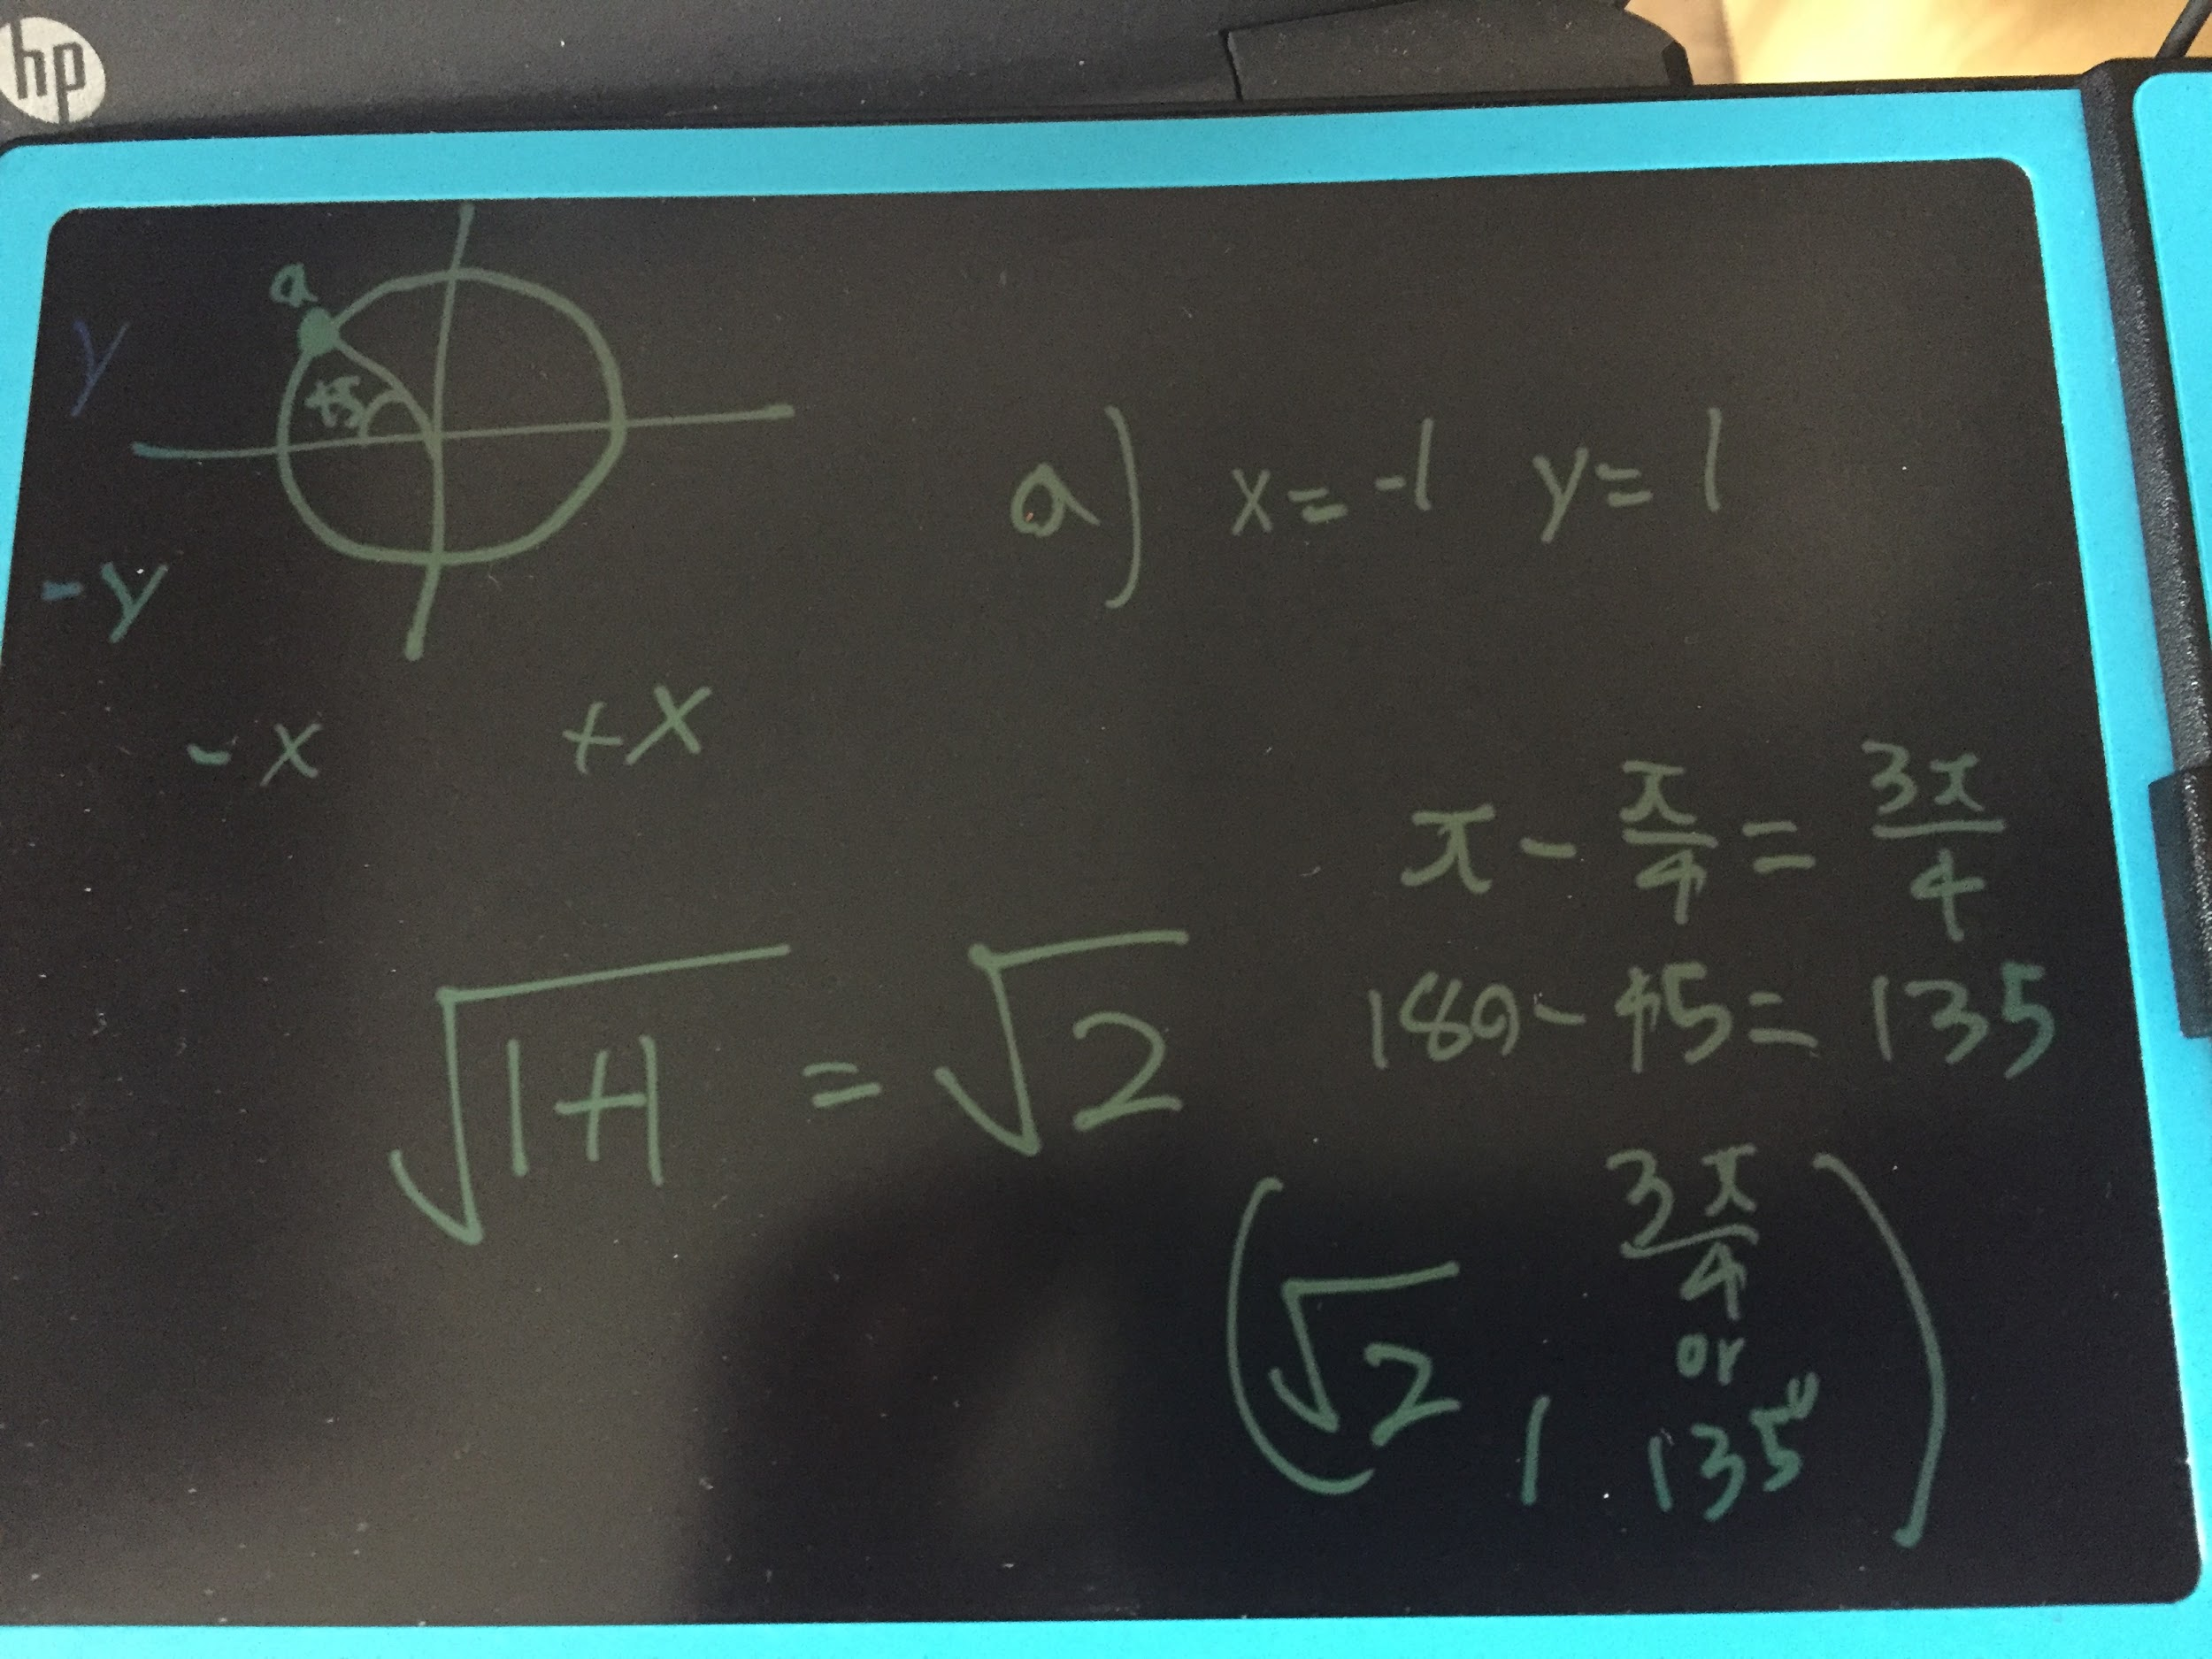

b) (x= -3, y= -3)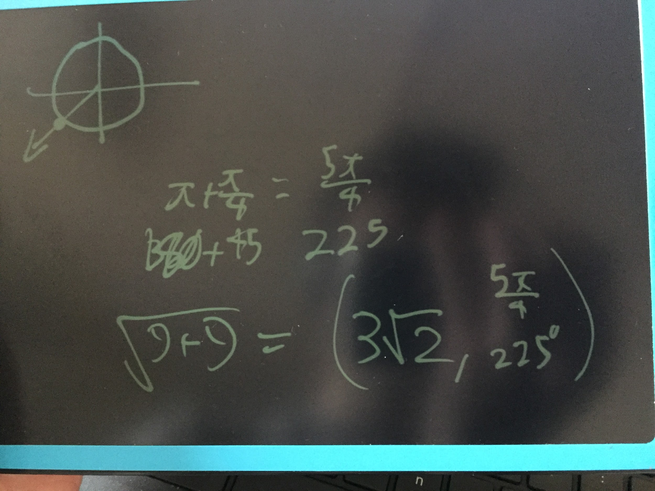

c) (x= -1, y=0)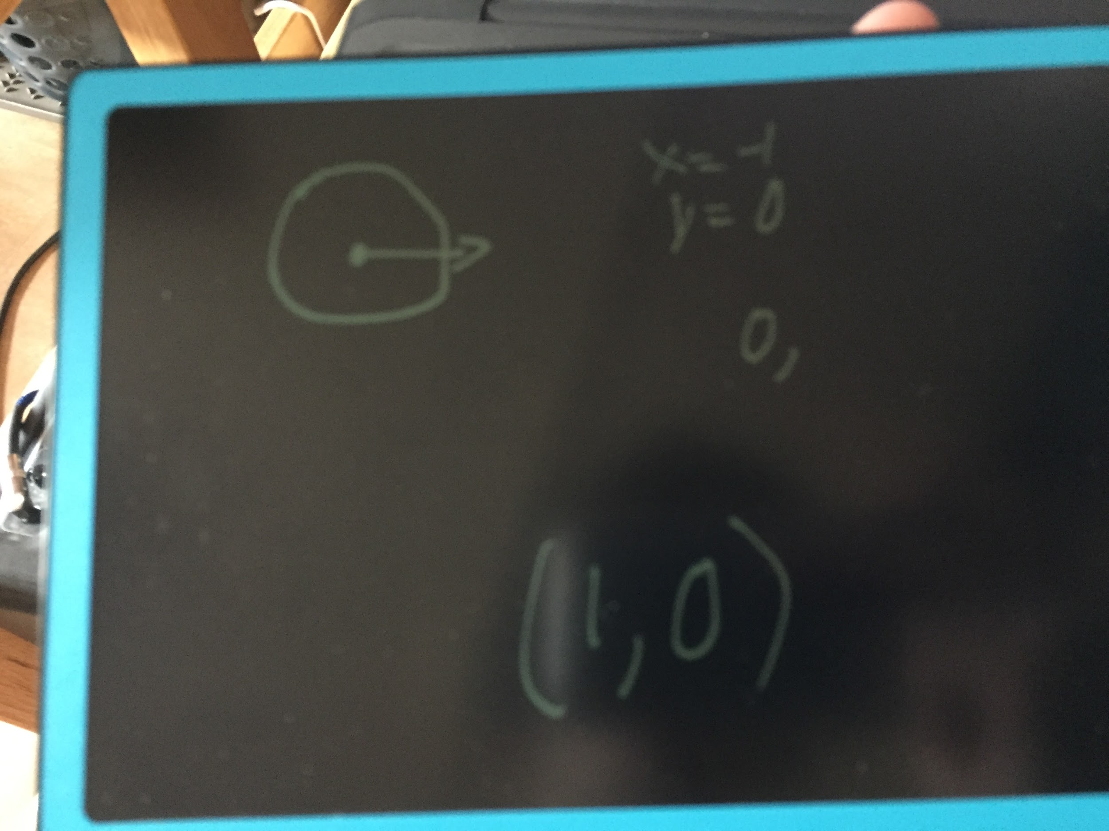

d) (x=0, y= -1)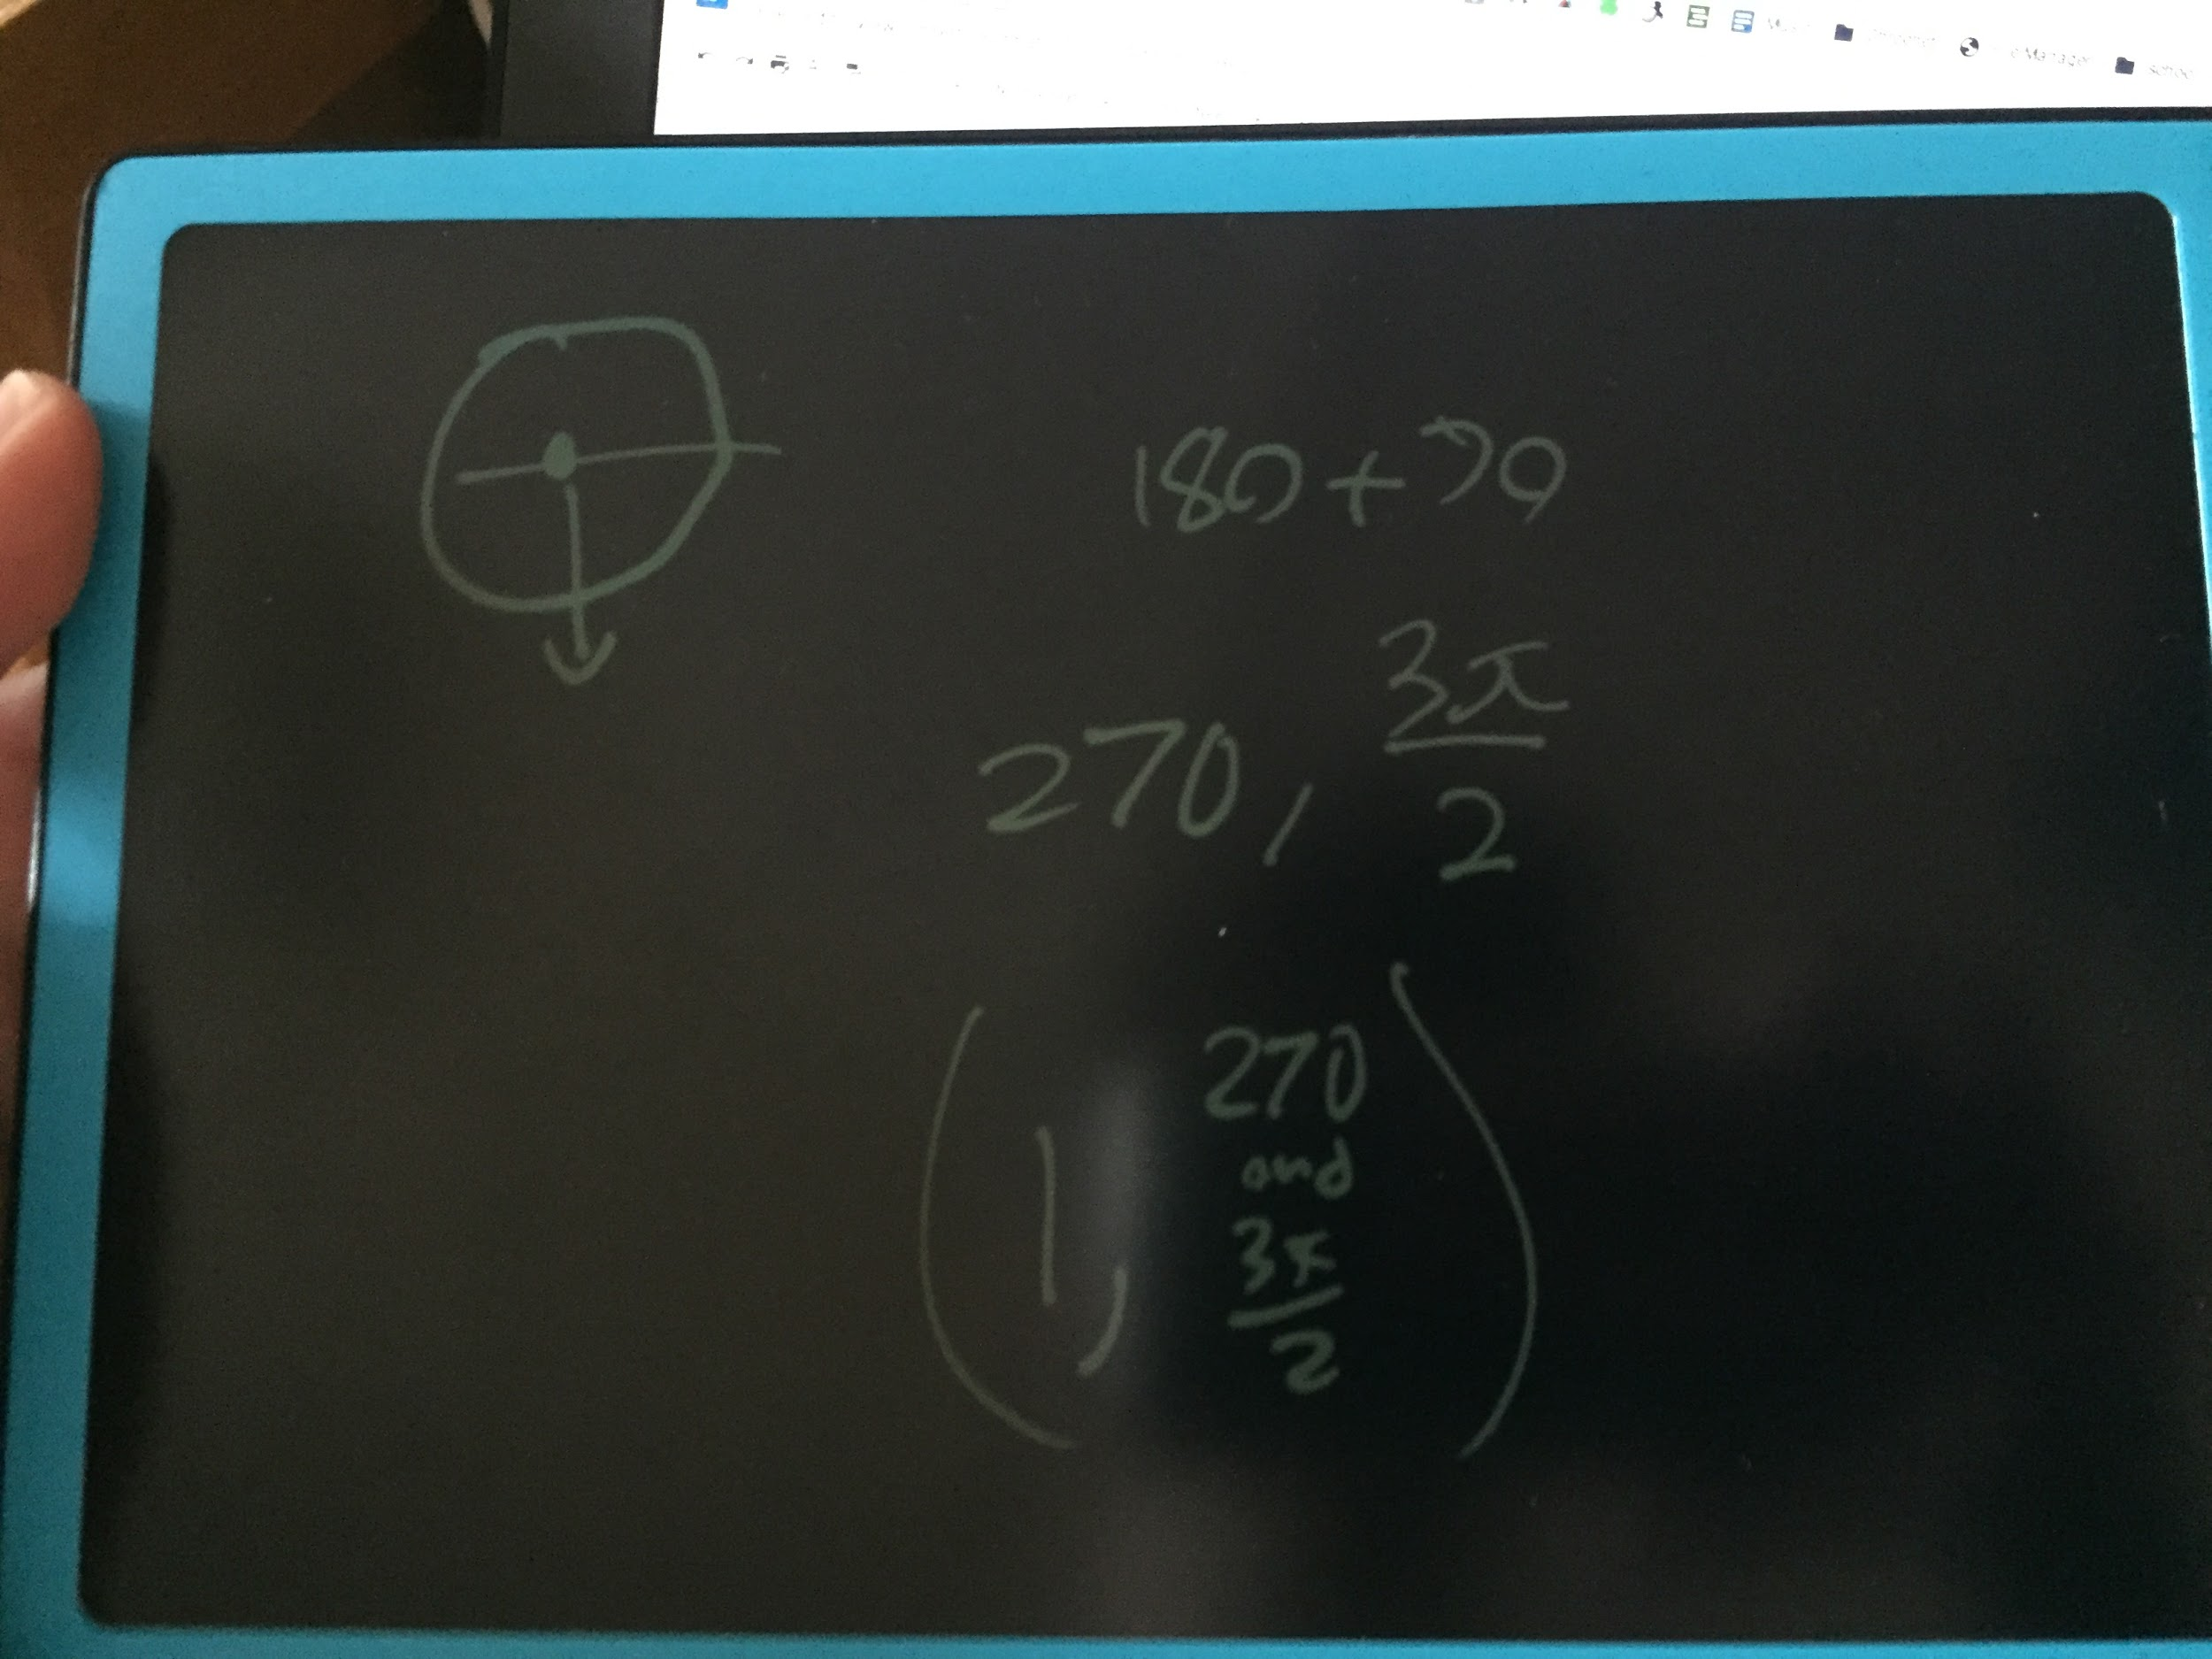

e) r= 4 , O=pi/6'

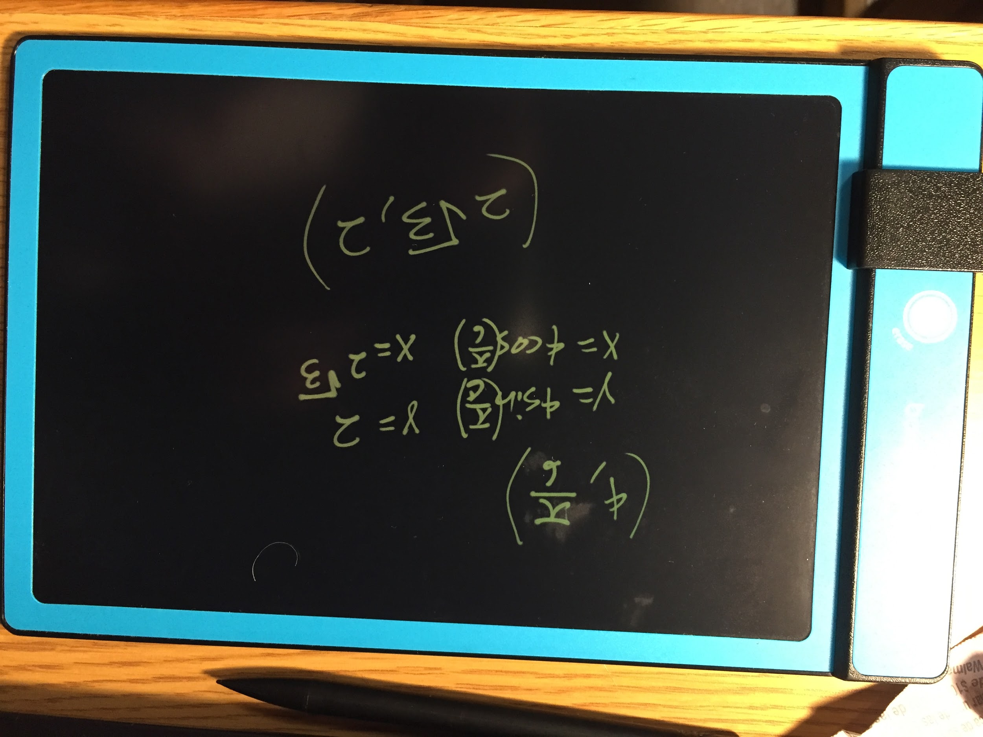

f) r = 4 , O =-3pi/4

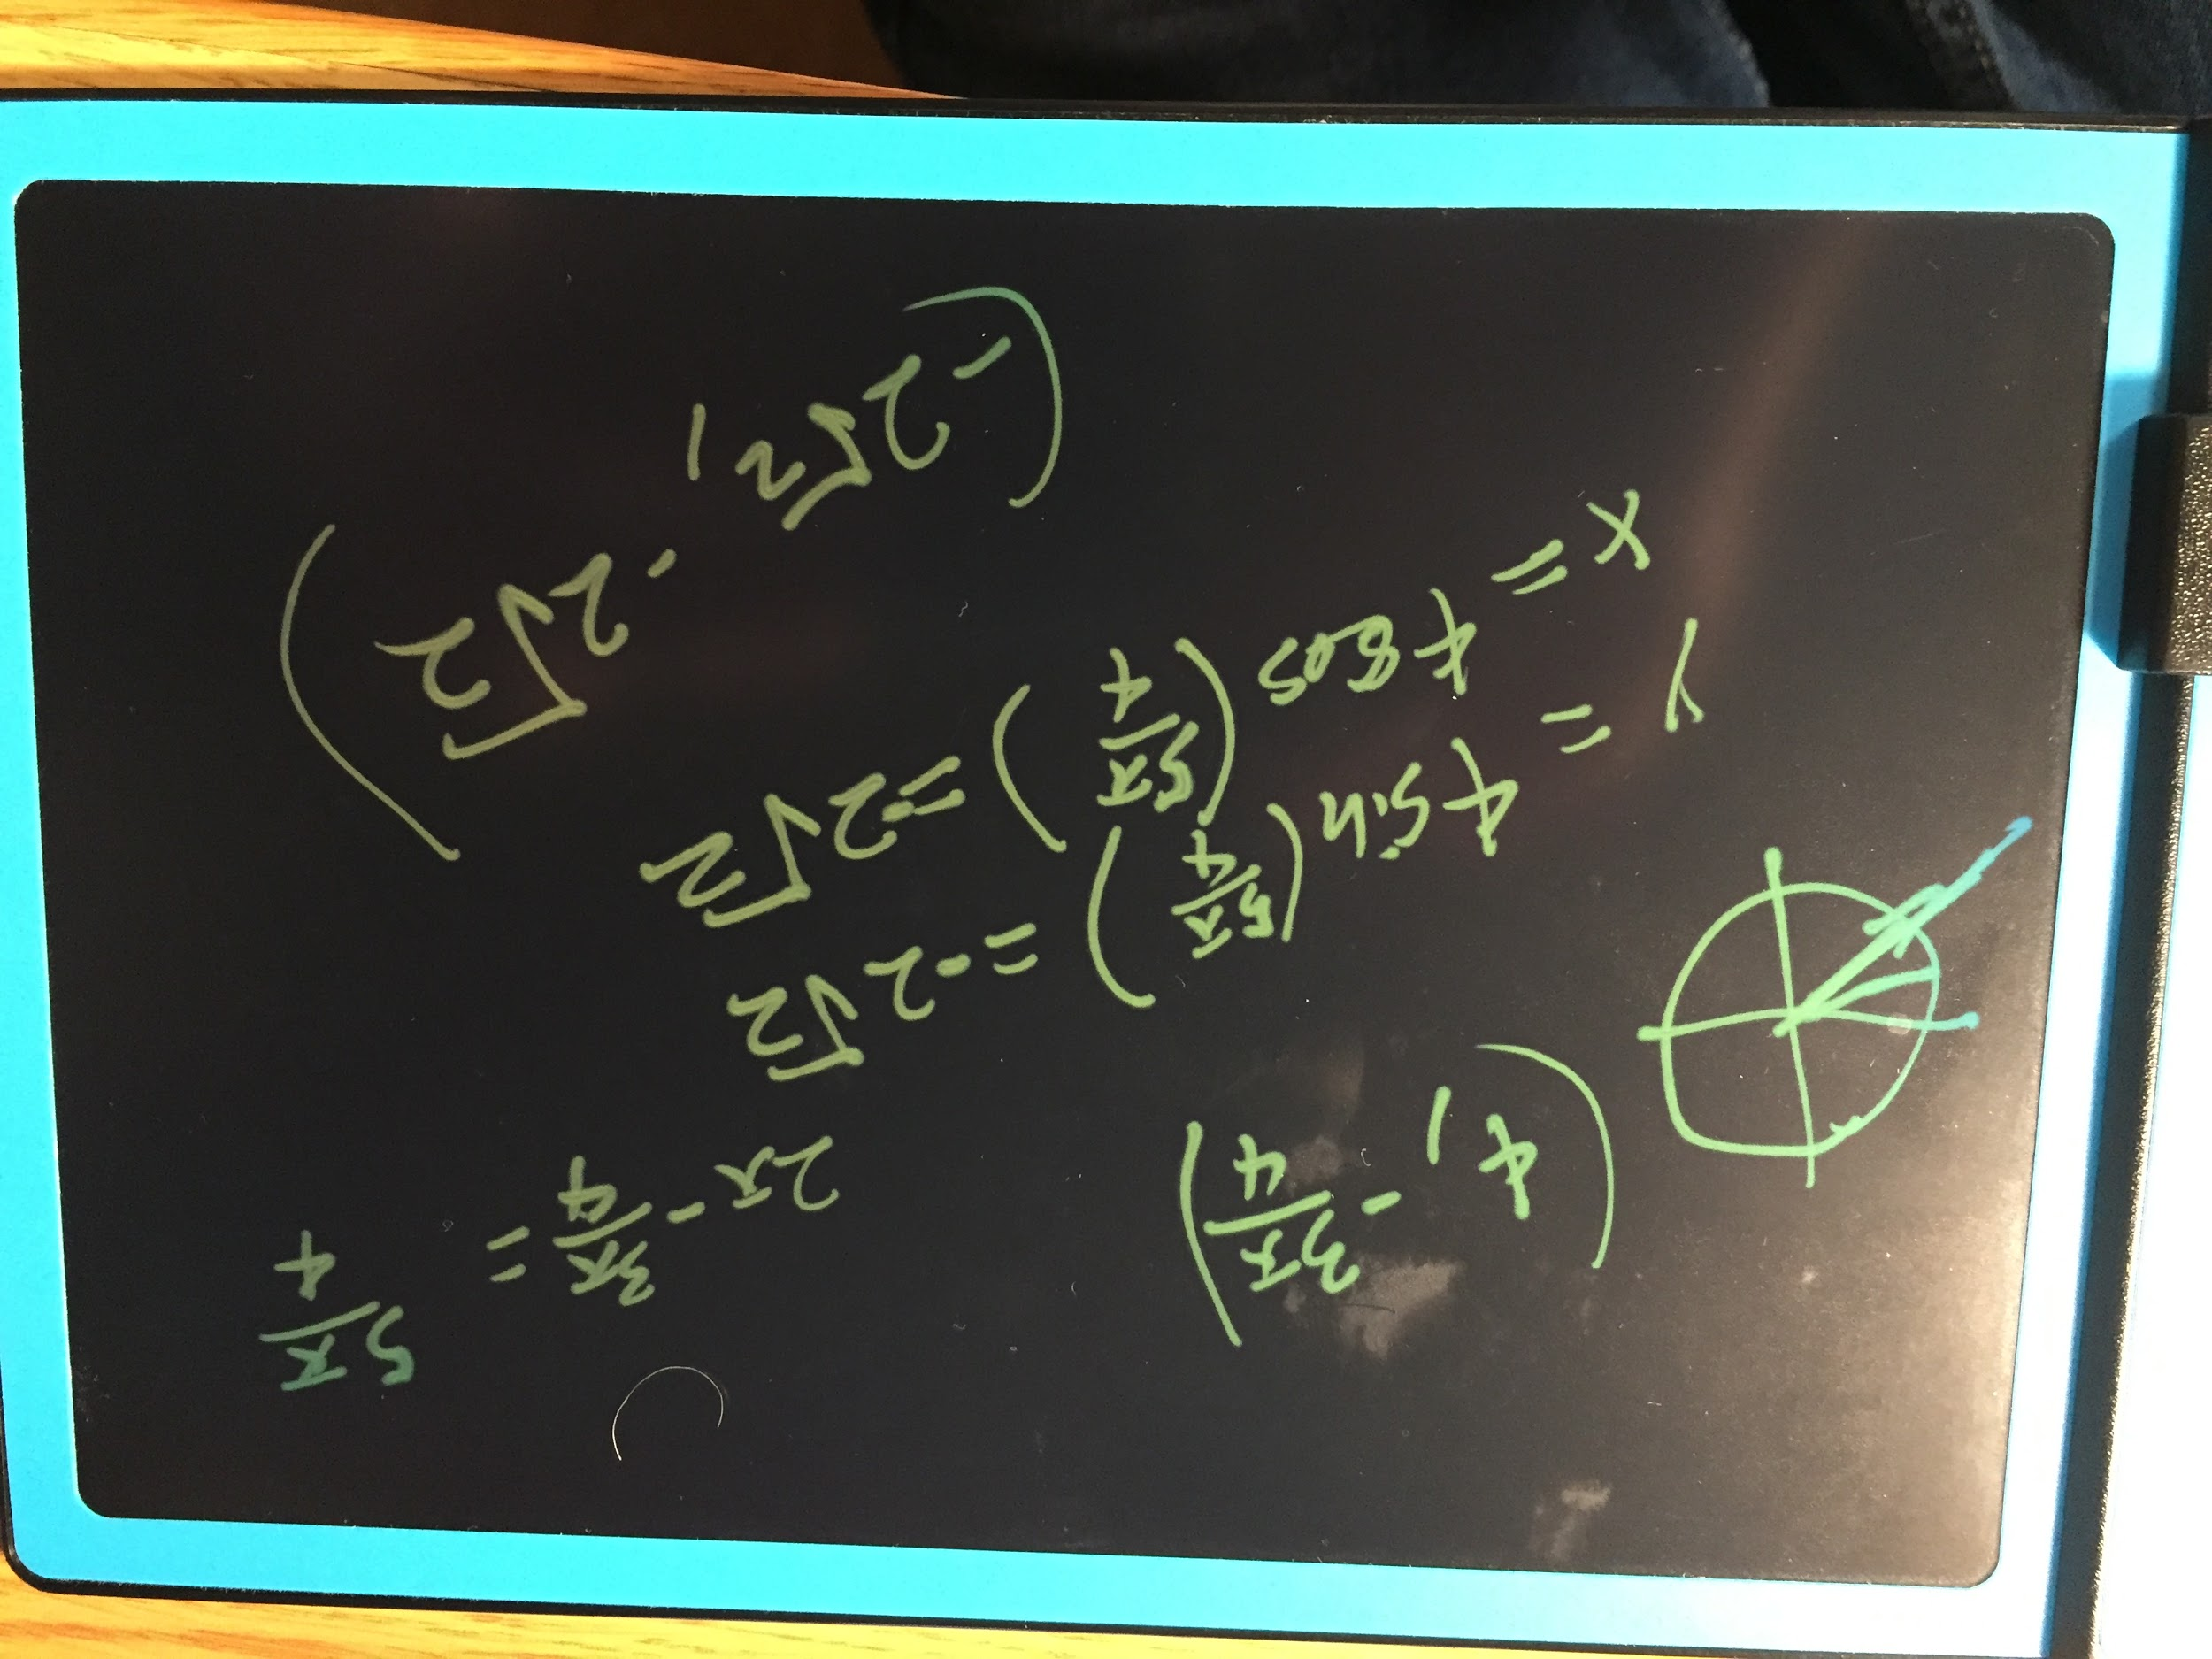

g) r= √2 , O = 5pi/4 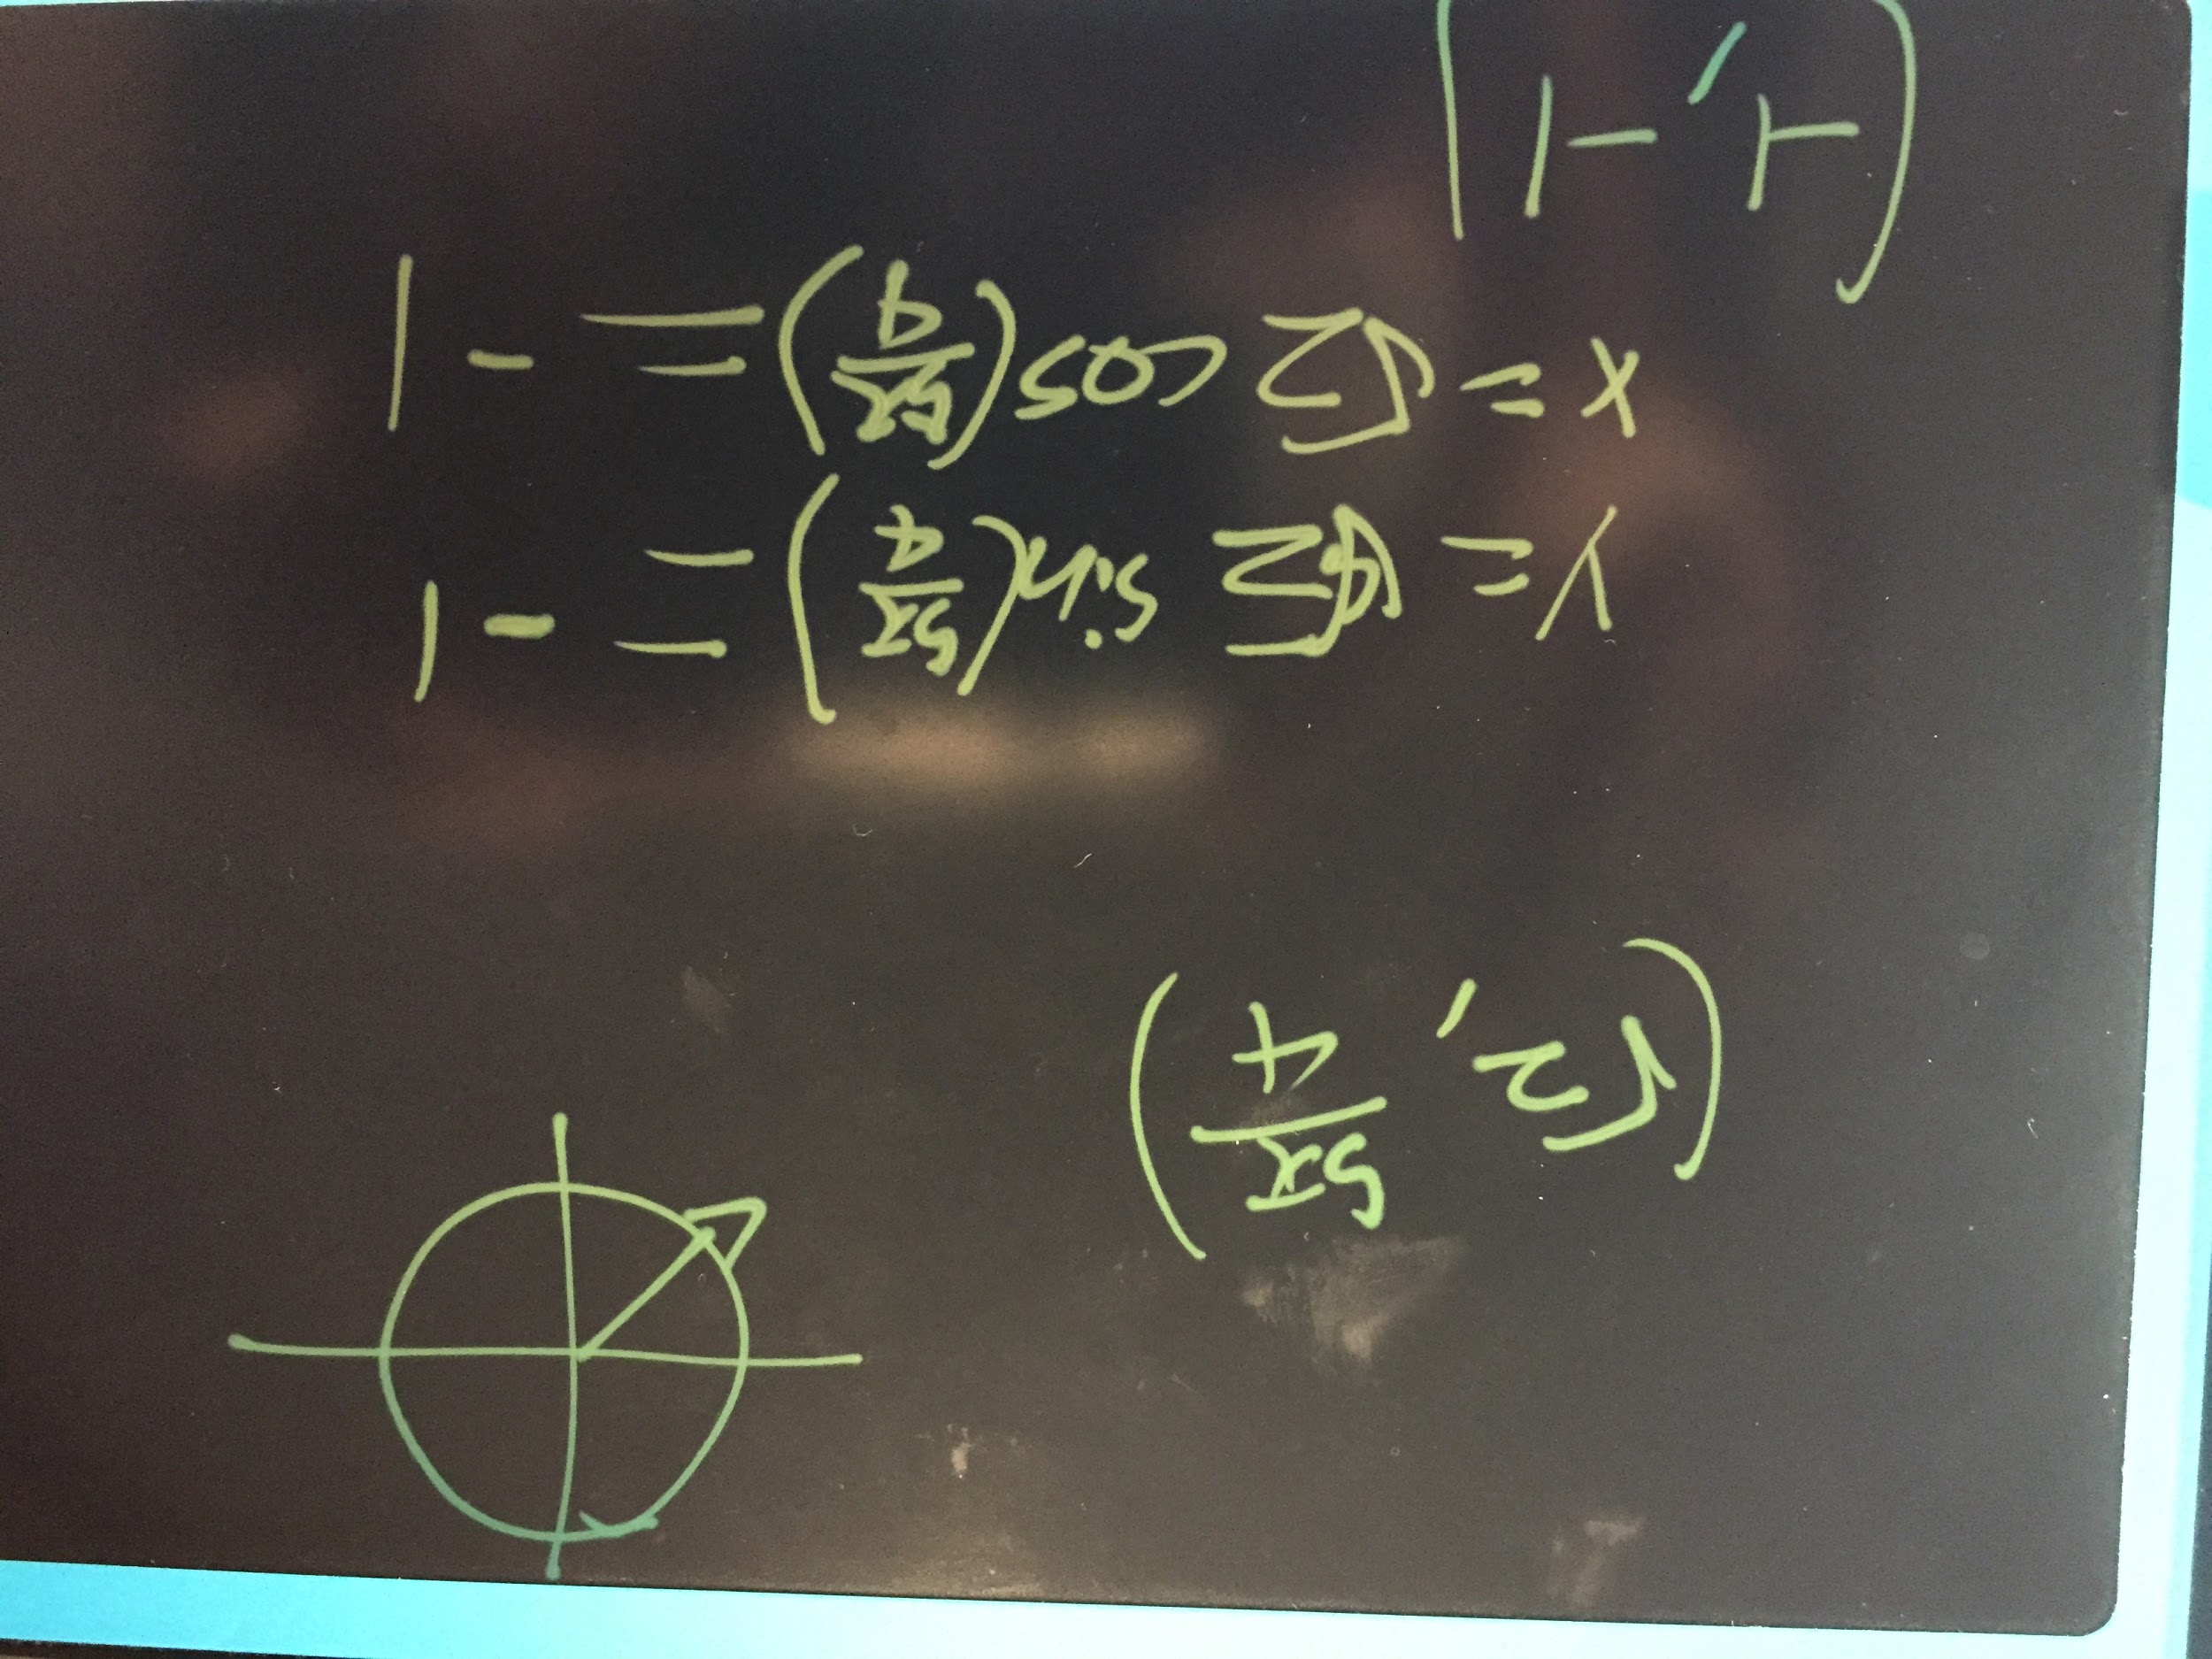

h) r = 5 , O = −3 pi

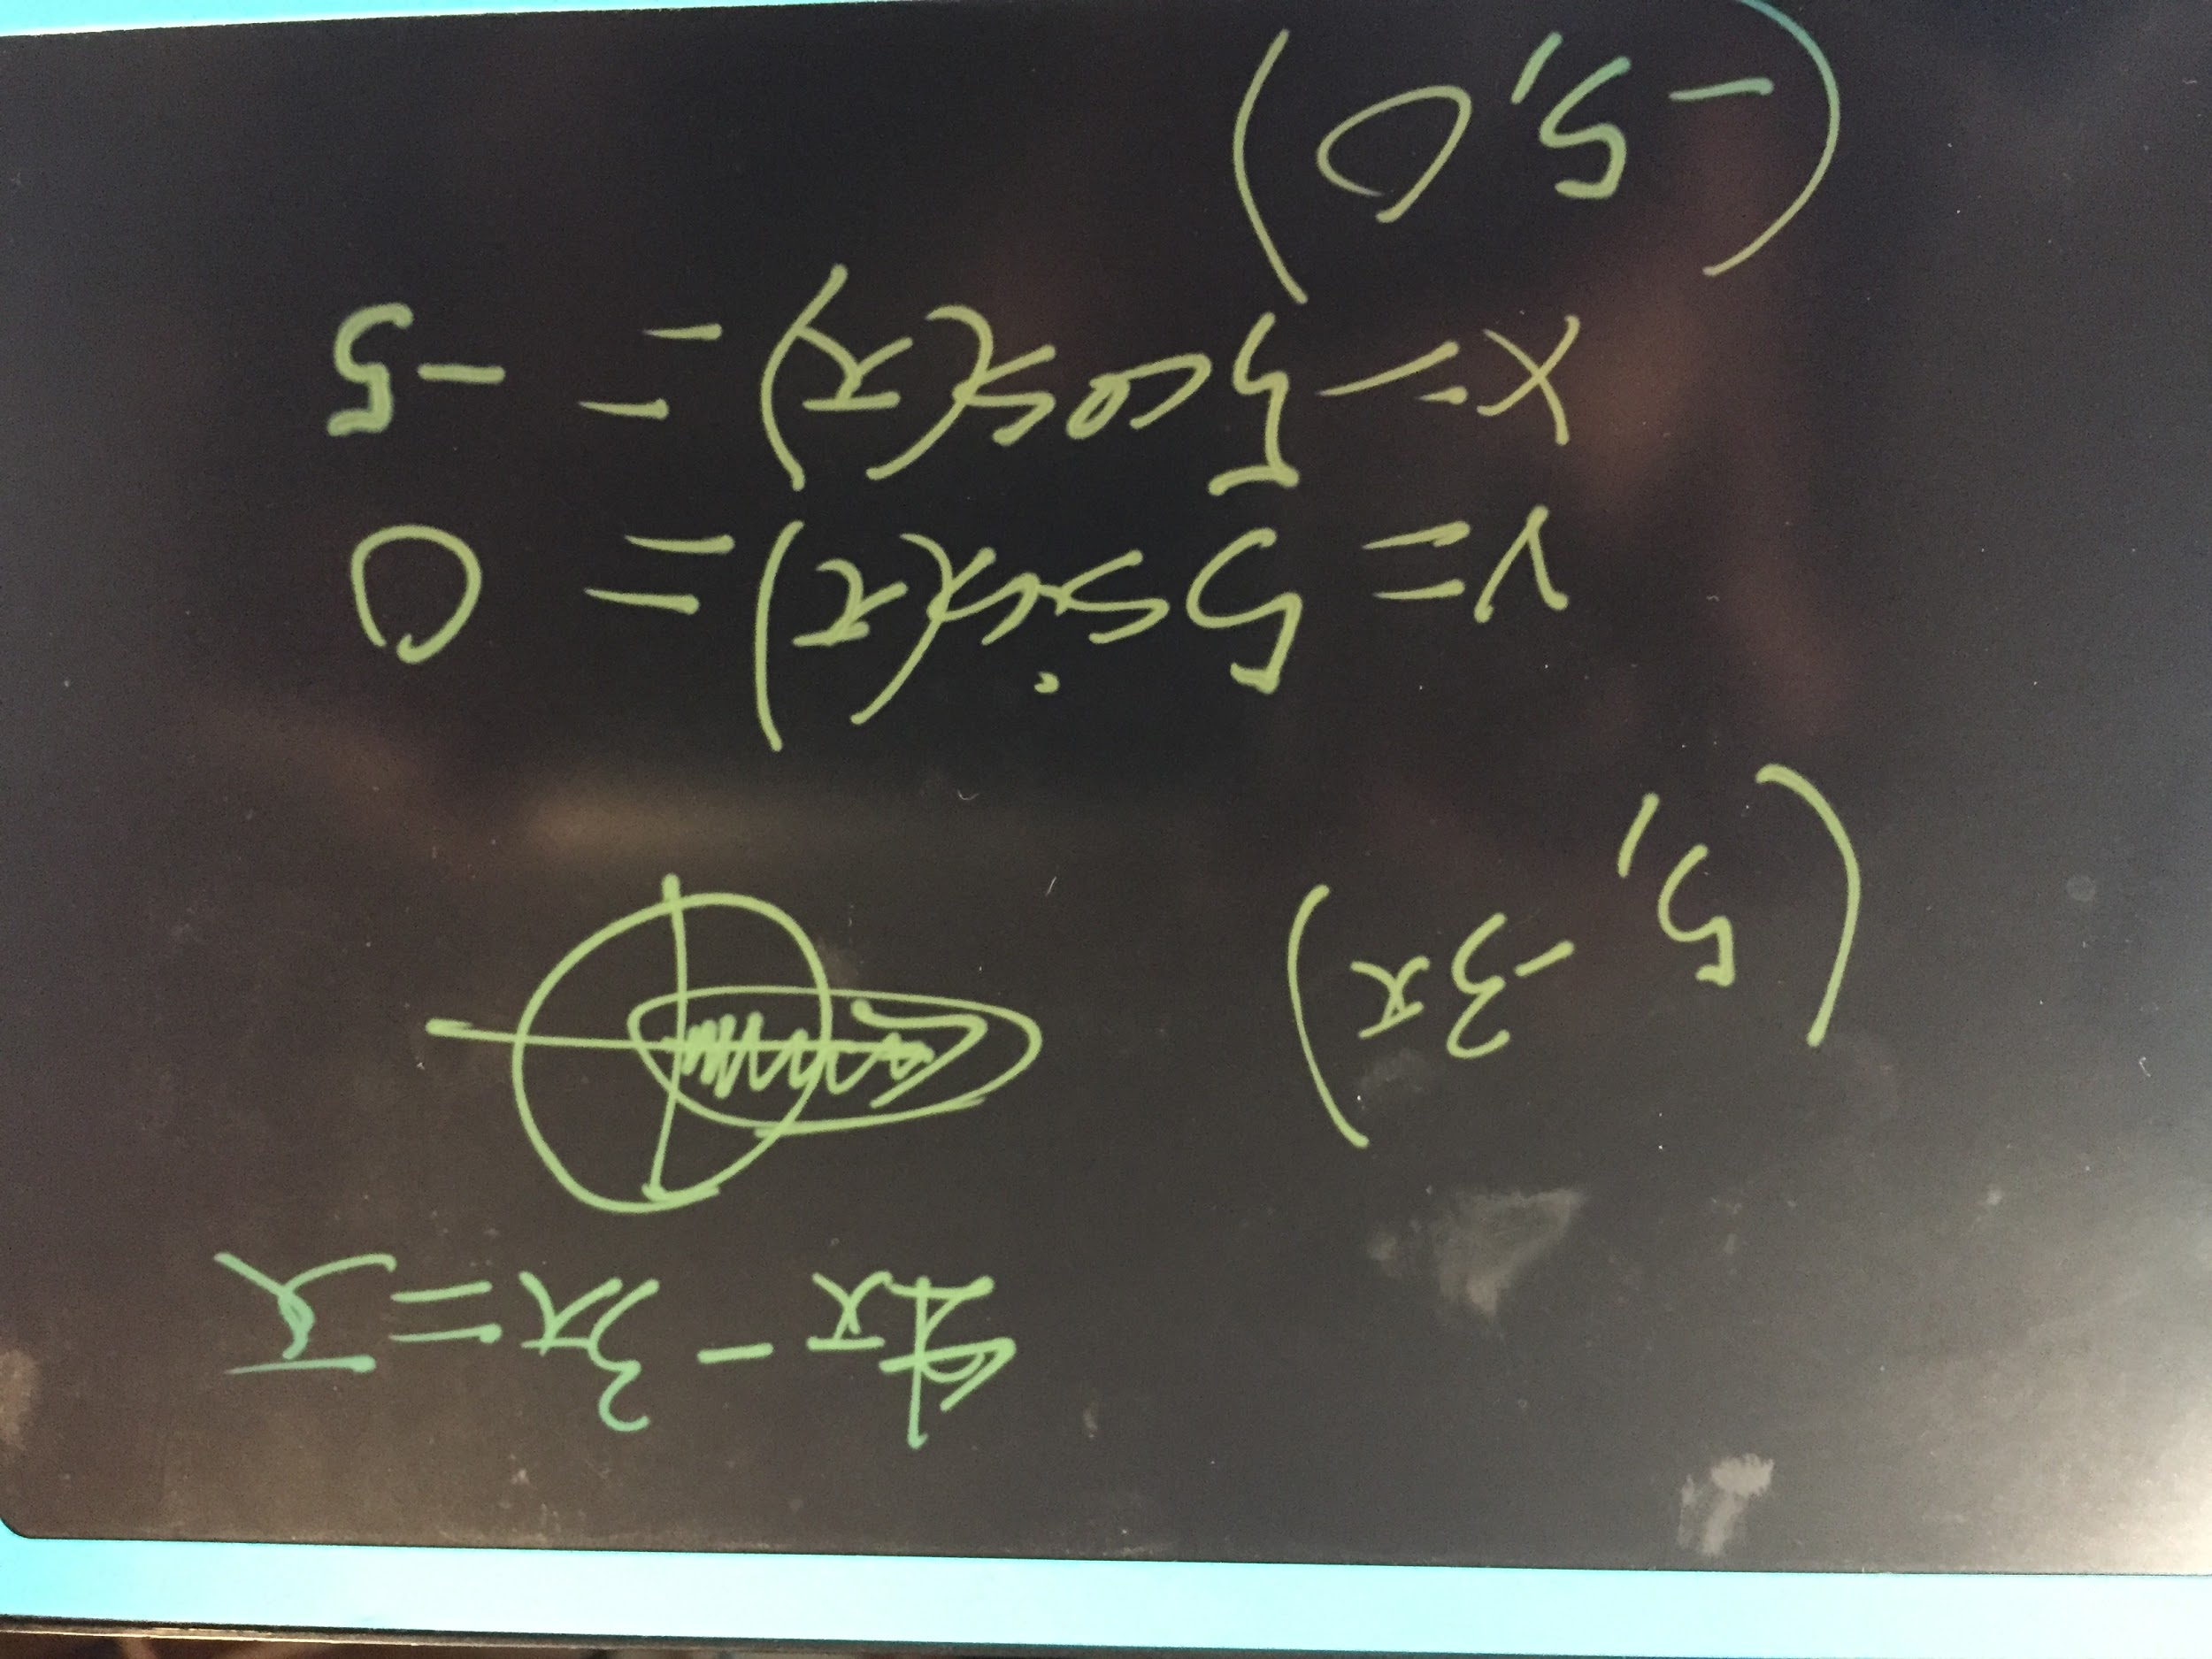

**Problem 3:**

1. What is this link/material about? Provide a summary.

The types of electrical engineering and the pros and cons to it. It explains how electrical engineering has been split into different types and how specialized it can get. Then it talks about the history of electricity.

2. What are the main points that the sites? What did you find interesting?

That the tools used between engineers can be vastly different.

3. What is the difference between Electrical and Electronics Engineering vs. Electrical Electronics Technicians Find/identify clear differences

3. What type of classes, subjects, and emphasis do you need to have to become an electrical

engineer according to the information?

Circuit Designing, Instrumentation & Electrical measurements, Power Transmission fundamentals, Electrical drive & Electrical machinery, Power electronics, Renewable energy fundamentals, Microcontroller & Programming languages, Presentation & Communication skills, Fundamentals of electrical power generation, Control systems & Control machinery, and Quality control analysis

Drawing project plans and circuit diagrams.

estimating costs

analyzing test data

1. What is this link/material about? Provide a summary.

Electrical and Electronics engineers, an overview of the job, work conditions, pay and how to become one. It then explains what they do and where they work.

2. What are the main points that the sites? What did you find interesting?

I found it interesting that electrical engineers made more than the average engineer.

3. What is the difference between Electrical and Electronics Engineering vs. Electrical Electronics Technicians Find/identify clear differences

3. What type of classes, subjects, and emphasis do you need to have to become an electrical engineer according to the information?

A degree from an ABET-accredited engineering program

A passing score on the Fundamentals of Engineering (FE) exam

Relevant work experience, typically at least 4 years

A passing score on the Professional Engineering (PE) exam

1. What is this link/material about? Provide a summary.

The roles and overview of what electrical technicians do.

2. What are the main points that the sites? What did you find interesting?

They help electrical engineers in design circuits, such as helping building prototypes.

3. What is the difference between Electrical and Electronics Engineering vs. Electrical

Electronics Technicians Find/identify clear differences

The technicians help the engineers and don't get paid as much.

3. What type of classes, subjects, and emphasis do you need to have to become an electrical

engineer according to the information?

Seems to need less formal education and rather more emphasis on training.

**Problem 4:**

1. Provide a summary of what is the chapter about?

Quick learning is not the most effective learning technique as it will ot stay for very long so constant practice doesn’t help for long term learning. The most important step in memory is retrieval. You can remember something but not be able to recall it at any particular time. How challenging positions are most effective and training should be similar to the actual experience.

2. Provide your reflections and learning about

a. What was interesting?

how the word forget means more losing cues rather than actually not remembering.

How random interval training is more effective than just repeating.

b. What was surprising?

How much we can remember even if we seem to forget almost everything.

How people with mastery are able to make perfect decisions because of repeated practice.

c. What are you learning from this chapter?

That failure is ok and is how we best learn, learning to fail in smaller ways (such as the falling example) is better than aiming for no failure.

d. What would you like to read more?

About the study of baseball batters and of masters at work and their thought process.

Mental Models

e. What are the questions you have?

How have we not adapted different learning techniques into the schools if these studies have been done so long ago?